“Items to help women run their household”

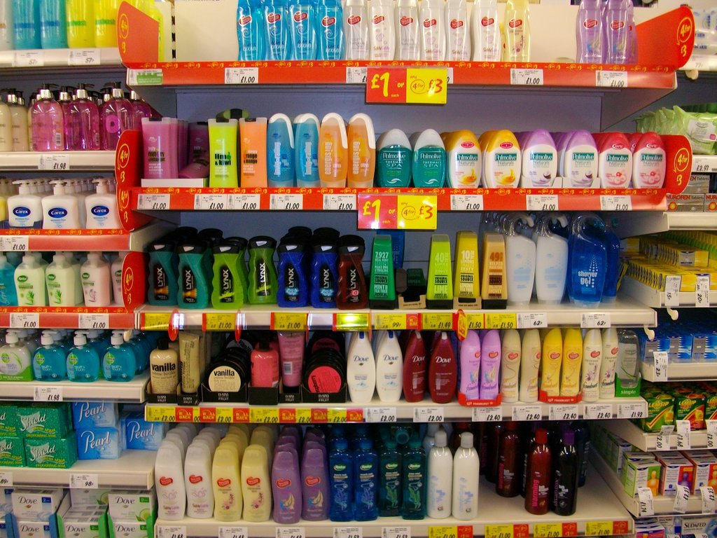

- Toilet paper
- Paper towels
- Tissues
- Napkins
- Laundry detergent.
- Dishwashing liquid
- Toothpaste, toothbrush, dental floss.
- Soap
- Diapers
- Tampons and pads
- Deodorant
- Hair-care products
- Cleaning products
- Trash can liners
- Food storage baggies
- Lotion, powder, sunscreen, lip balm, etc.
- New Women’s underpants
- Gift cards to Shop Rite are especially helpful.

